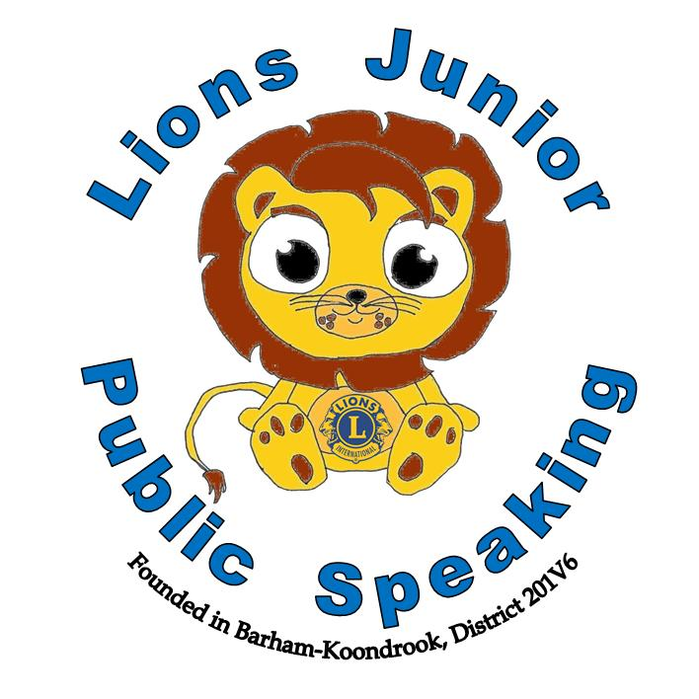
Region Click here to enter text.
District Click here to enter text.
District Representative
Click here to enter text.
Date
District Chairman
This certificate is awarded to
“The World is waiting for YOUR words” ~ Arvee Robinson
This certificate is awarded to
Date
Club President

Lions Junior Public Speaking
Region Click here to enter text.
District Click here to enter text.
District Runner Up
Click here to enter text.
Date
District Chairman
This certificate is awarded to
“The World is waiting for YOUR words” ~ Arvee Robinson
This certificate is awarded to
Date
Club President

Lions Junior Public Speaking
Region Click here to enter text.
District Click here to enter text.
This certificate is awarded to

Click here to enter text.
District Final Participant
Click here to enter text.
Date
District Chairman
“The World is waiting for YOUR words” ~ Arvee Robinson
This certificate is awarded to
Date
Club President

Lions Junior Public Speaking

