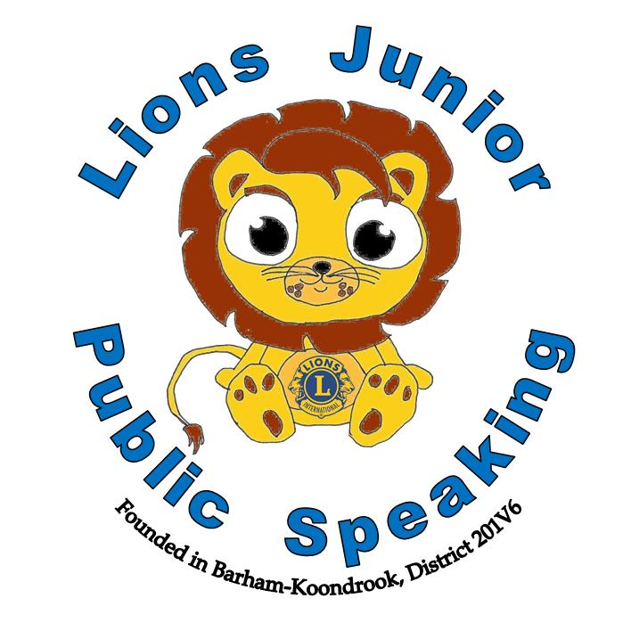
Most Outstanding Speaker
Click here to enter text.
Click here to enter text.
Date
Club President
This certificate is awarded to
Lions Club of Click here to enter text.
District Click here to enter text.
“The World is waiting for YOUR words” ~ Arvee Robinson
This certificate is awarded to
Date
Club President

Lions Junior Public Speaking
Runner Up
Click here to enter text.
Click here to enter text.
Date
Club President
This certificate is awarded to
Lions Club of Click here to enter text.
District Click here to enter text.
“The World is waiting for YOUR words” ~ Arvee Robinson
This certificate is awarded to
Date
Club President

Lions Junior Public Speaking
This certificate is awarded to

Click here to enter text.
School Final Participant
Click here to enter text.
Click here to enter text.
Date
Club President
Lions Club of Click here to enter text.
District Click here to enter text.
“The World is waiting for YOUR words” ~ Arvee Robinson
This certificate is awarded to
Date
Club President

Lions Junior Public Speaking

