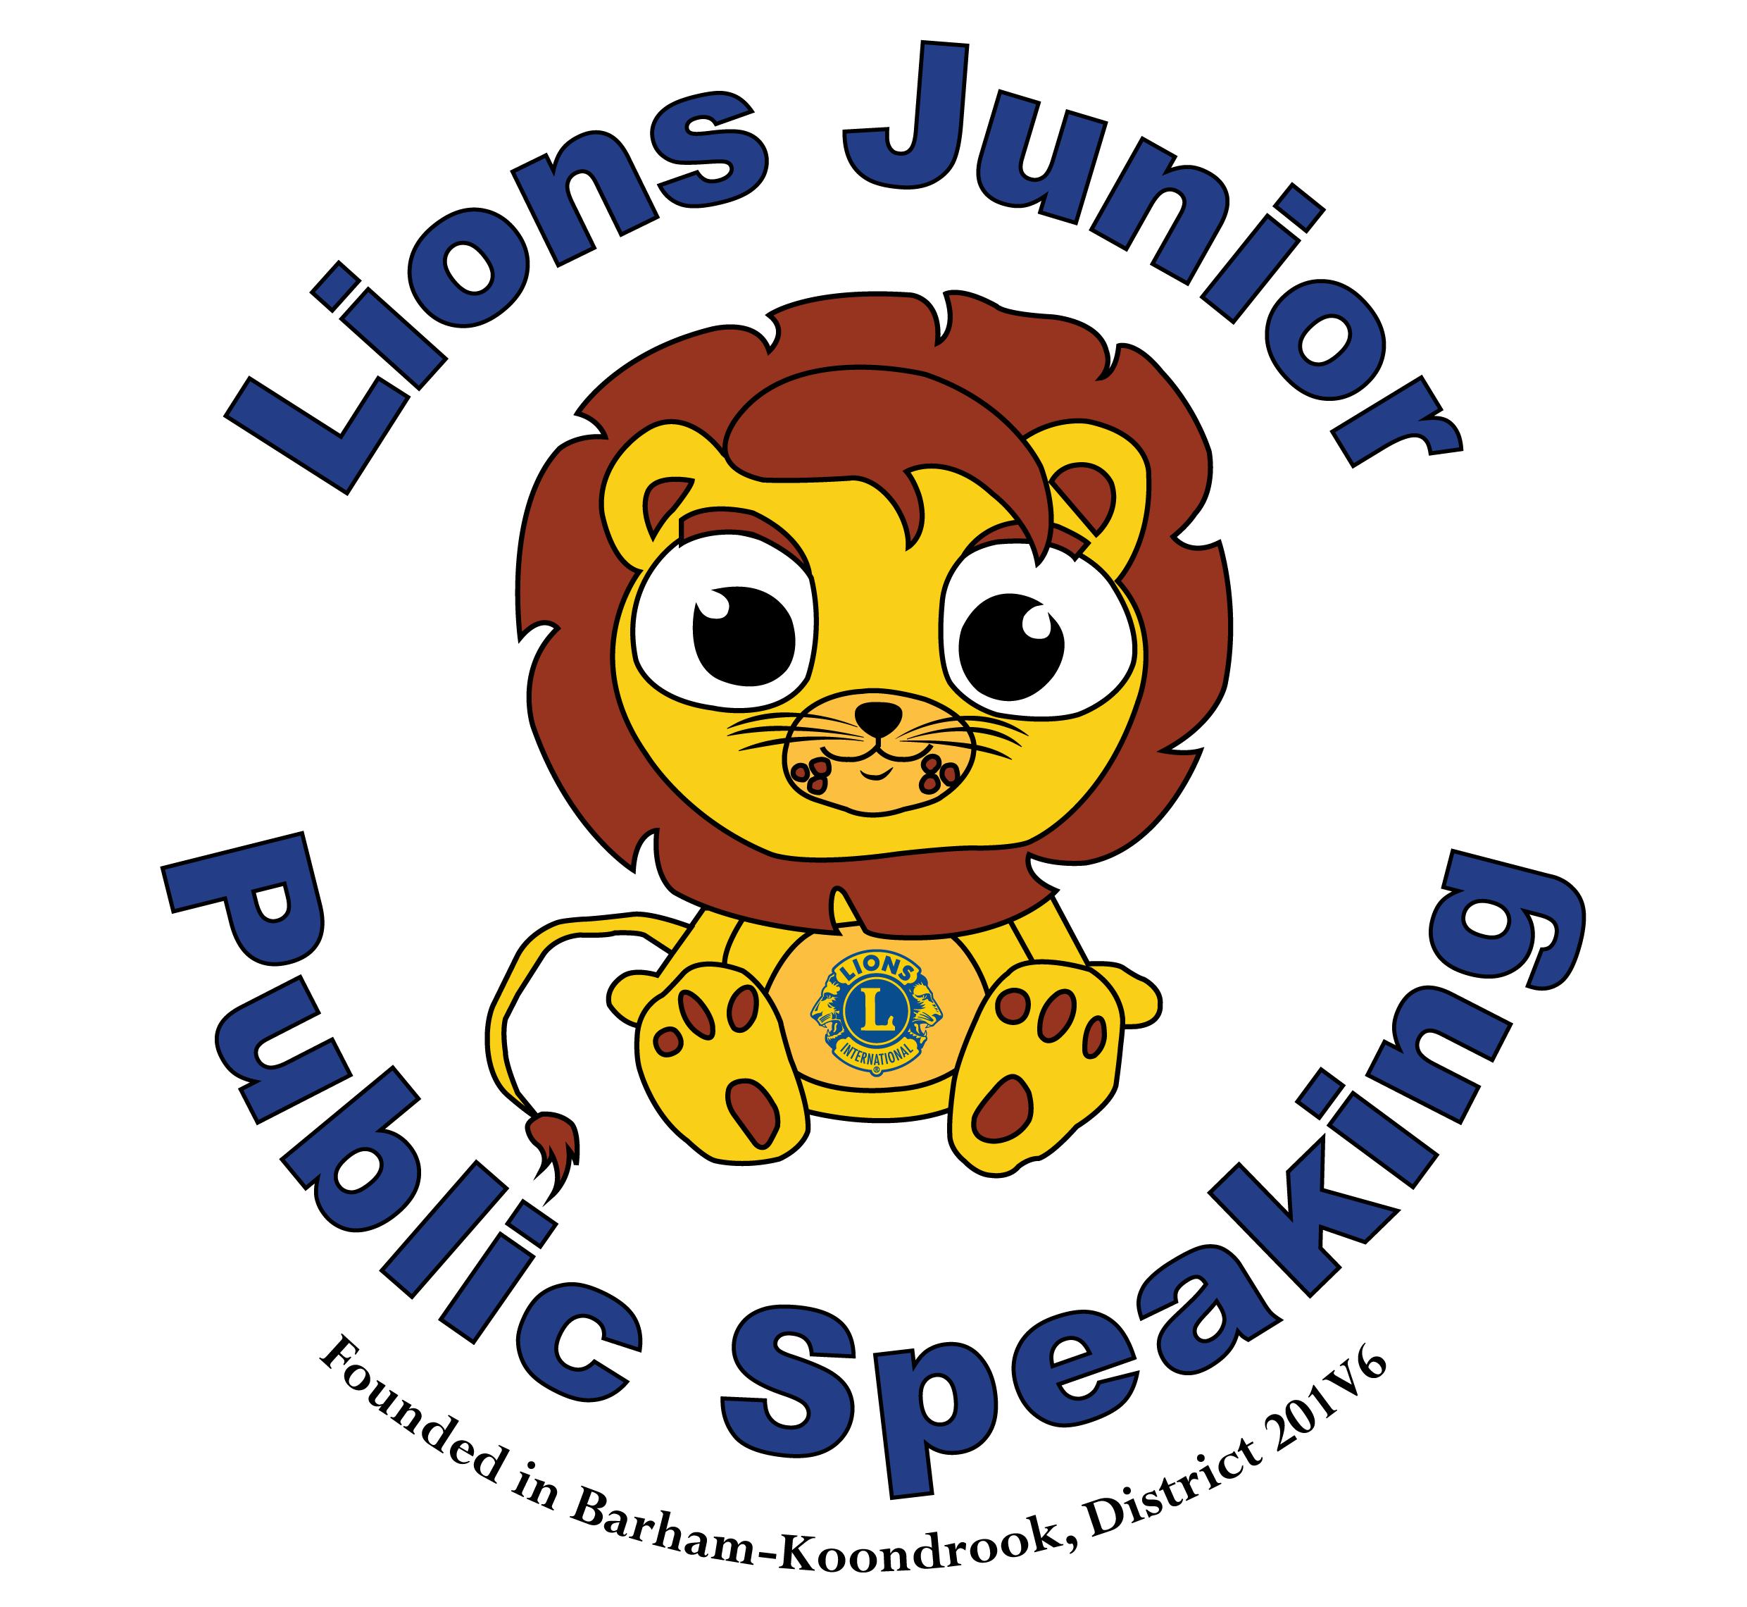

Lions Clubs Junior Public Speaking

Information for Judges

Club/Zone/Region/District

Level Competition

Thank You for being one of our Judges, we appreciate the time you have taken to help us with our program. Contestants have been selected to represent their Lions Club/Zone/Region/District.

Each student has been asked to prepare a speech on a set topic. They have delivered this speech a number of times to reach this level of the competition.

You have a hard task ahead of you - to choose only one (1) student to be the “Winner” from each year level (years 3/4 & 5/6) who will then move forward to the next Finals level. You will also need to select a “Runner Up”.

In addition, year 5/6 students will be given 10 minutes to prepare a speech on a topic that will be set tonight in conjunction with the Judges and Club organiser. This has been included as an added challenge for students who have already shown they are skilful at preparing and delivering a prepared speech.

Remember that some students may not be noticeably confident. Please be positive in your feedback and encourage them to improve.

A little about this program...
This program has been running successfully since 2007 in the 201V6 District. In 2016 it became a Multiple District project. Each year, more and more Schools, Clubs and Districts are becoming involved. Students really enjoy the program and reap the benefits for years to come. Teachers are enjoying the program and making it part of their class curriculum as it incorporates story writing, research, speaking in front of the class, etc.
We have seen quiet, shy students, too timid to speak...stand up and deliver a speech that has simply blown judges away and they have gone on to win the Competition. It’s amazing what this program can do for the kids that participate - not to mention the benefits that Lions Club members receive as well.
The aim of this part of the program is to give as many students as possible the opportunity and ability to research, compose and present a speech on a given topic to an audience of their peers!

How does this program work?
Prepared Speeches
Students have been given a topic and have been asked to prepare a speech on this topic.
Years 3/4 are asked to prepare a three (3) minute speech, with a single warning bell at 2 1/2 minutes and a double warning bell at 3 minutes.
Year 5/6 are asked to prepare a four (4) minute speech, with a single warning bell at 3 1/2 minutes and a double warning bell at 4 minutes.
On the sound of the double warning bell, students are NOT expected to stop speaking immediately. They should finish their sentence/paragraph and end their speech.
Penalties for time may come into the judging if your scores are close.

Short Preparation Speech (Year 5/ 6 students only – club, region, district & state levels)
Grade 5/6 students will also be required to give a one-minute speech on a topic selected by Lions and/or Judges. While only worth 10 points, it is important that students have an introduction, body & closing - similar to their prepared speeches. You can use the criteria for the prepared speeches as a guide for judging.
Students will be taken from the main area of the room & separated. The question will be given to each student and they will each have 10 minutes to prepare their speech. At the completion of this 10 minutes, students will return to present their speech.
The question will be read (either by a judge or the program organiser).
Their time starts at the completion of the question being read.
Timekeeper - Students will hear a double bell at 1 minute.

Rules of the Program…
As with any competition, there are some rules to follow, so that everyone has the same opportunity.

There is judging criteria which needs to be followed and we prefer the use of the JPS Score sheet.

Presentation of Speeches - Students should present their speeches from the floor or stage without the use of:
- props, photo’s, or slideshows during their speech
- lecterns (where possible/practical students should not stand behind a bulky lectern) - this allows for judges to see the student clearly - we encourage students to use palm cards instead of large sheets of paper.
- MICROPHONES are allowed. BUT not all schools/clubs, etc will use one - it is not necessary to use one if you do not have access to one. Students should still be encouraged to use a loud, clear voice when speaking. A Microphone will be offered to students to use at the District Final, if they wish to use it.

Judging Criteria
Students will be judged on the following, with score sheets provided for you.

CONTENT
- Beginning – begins in an interesting way, grabs attention, has main points
- Central Theme evident and logical sequence developed
- Research – supports opinions with facts and/or examples
- Language – Appropriate use of language – clear, correct sentences, words well chosen, informative
- Ending – strong, summary of main points, as close to time as possible.

DELIVERY
- Visual – Confidence, stance, unobtrusive use of notes
- Eye Contact
- Use of gestures to convey message
- Voice – clear, varied expression, pace, projection, etc
- Engagement

Most importantly today...Enjoy! Listen and enjoy the speeches that the children present.
You will find yourself amazed at their level of confidence and ability - and you may even find you learn a thing or two!

Thank you again for your time and assistance today.

