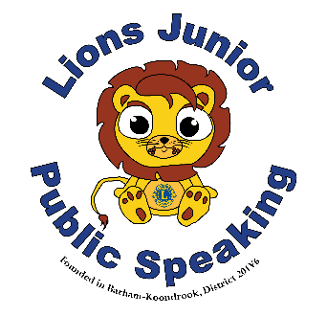
Lions Clubs Junior Public Speaking
Short Preparation Speech
For the Supervisors (Chaperones)

When all students in Years 5/6 have completed their set topic speeches, take all students to a separate room or space where they can prepare for the next topic. They should not be able to hear what is being said in the main room
- The explanatory section should be read to all students first.
- The first student is issued with a copy of the question and explanation. Succeeding students should be issued at one minute intervals.
- Students are not allowed to talk except to ask the supervisor for clarification on the topic.
- After 10 minutes preparation, the first student should be taken back to the audience to deliver their speech. The others can continue writing until their 10 minutes is up – and then will follow in the same order they presented their prepared speeches.
- The judge will ask the question and time starts from when the judge finishes speaking. Emphasise this to each student as they leave.
Explanatory Note
To be read by the supervisor to the group and a copy along with the question to be given to each student.
You are given 10 minutes to prepare a short 1 minute speech on the topic given to you. You may not talk during this time except to ask your supervisor about something you do not understand about the topic.
- Your speech should include:
- An introductory statement
- One or more explanatory statements
- A concluding statement

When you are taken back to the room to present your speech, a judge will read the question to you. Your time starts when the judge finishes speaking. You do not have to go through a formal introduction to the audience or judges. Just go straight into your speech when the judge finishes asking you the question.

SPEECH TOPIC – (Supervisors – do not read this part out loud!)
Short Preparation Speech - Explanatory Note to Students
To be read by the supervisor to the group and a copy, along with the question, to be given to each student.
You are given 10 minutes to prepare a 1-minute speech on the topic given to you. You may not talk during this time, except to ask your supervisor about something you do not understand about the topic.
At the completion of 1 minute, you will hear a double warning bell.
Your speech should include - An introductory statement, one or more explanatory statements and a concluding statement.
When you return to present your speech, the question will be read to you, your time starts when the judge/chairman finishes the question. You do not have to introduce yourself - it’s just as if you were answering the person who has asked the question.
Your Question is….

"
Short Preparation Speech - Explanatory Note to Students
To be read by the supervisor to the group and a copy, along with the question, to be given to each student.
You are given 10 minutes to prepare a 1-minute speech on the topic given to you. You may not talk during this time, except to ask your supervisor about something you do not understand about the topic.
At the completion of 1 minute, you will hear a double warning bell.
Your speech should include - An introductory statement, one or more explanatory statements and a concluding statement.
When you return to present your speech, the question will be read to you, your time starts when the judge/chairman finishes the question. You do not have to introduce yourself - it’s just as if you were answering the person who has asked the question.
Your Question is….

"
Short Preparation Speech - Explanatory Note to Students
To be read by the supervisor to the group and a copy, along with the question, to be given to each student.
You are given 10 minutes to prepare a 1-minute speech on the topic given to you. You may not talk during this time, except to ask your supervisor about something you do not understand about the topic.
At the completion of 1 minute, you will hear a double warning bell.
Your speech should include - An introductory statement, one or more explanatory statements and a concluding statement.
When you return to present your speech, the question will be read to you, your time starts when the judge/chairman finishes the question. You do not have to introduce yourself - it’s just as if you were answering the person who has asked the question.
Your Question is….

