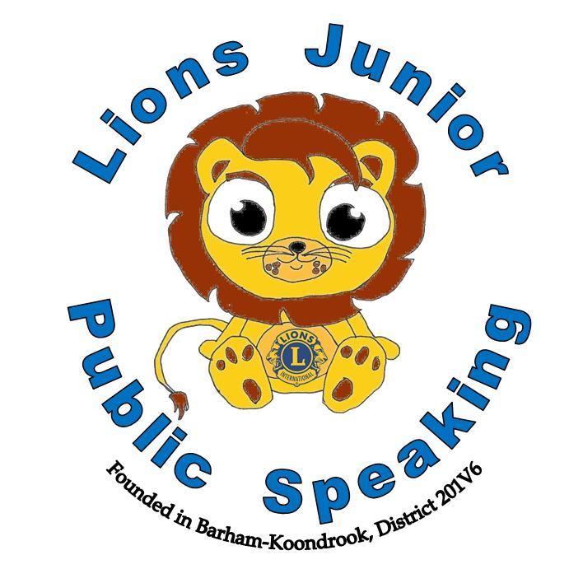

**Region** Click here to enter text.

**District** Click here to enter text.

**District Representative**

Click here to enter text.

Date

District Chairman

This certificate is awarded to

“The World is waiting for YOUR words” ~ Arvee Robinson

This certificate is awarded to

Date

Club President

Lions Junior Public Speaking



**Region** Click here to enter text.

**District** Click here to enter text.

**District Runner Up**

Click here to enter text.

Date

District Chairman

This certificate is awarded to

“The World is waiting for YOUR words” ~ Arvee Robinson

This certificate is awarded to

Date

Club President

Lions Junior Public Speaking

**Region** Click here to enter text.

**District** Click here to enter text.

This certificate is awarded to

Click here to enter text.

**District Final Participant**

Click here to enter text.

Date

District Chairman

“The World is waiting for YOUR words” ~ Arvee Robinson

This certificate is awarded to

Date

Club President

Lions Junior Public Speaking