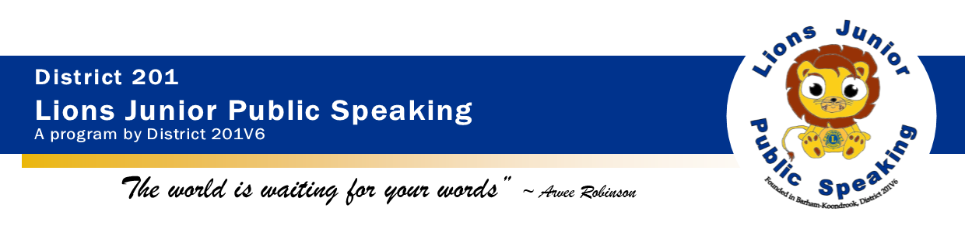**Lions Junior Public Speaking Program – Insert Club Name Lions Club Risk Assessment Procedure**

**Definition**

Risk Assessment: The process carried out to review physical and procedural factors that are hazardous to Lions and program participants.

# Introduction

Club Name Lions Club have an obligation to operate safe programs.

One of the strategies to achieve this is to conduct regular, formal assessment of each program and activity. The Club Name Lions Club strives to meet the standards set by Lions Junior Public Speaking Child Safety Procedure & Lions Australia Child Safe Policy and current State Government Working with Children requirements.

# Procedure

1. Hazards will be assessed according to the risk matrix below. Any hazards assessed as HIGH, will be given priority for resolution.
   1. Assess Likelihood and Consequence
   2. Match codes against Matrix
   3. Assess if risk is HIGH, MEDIUM or LOW according to the codes.
2. The board meeting will review the report and comment on the assessment. The President will then confirm the final report.
3. Lions will set timeframes for eliminating each identified hazard.
4. Action on the risk assessment will be reviewed at the next board meeting.

|  |  |  |  |  |  |  |
| --- | --- | --- | --- | --- | --- | --- |
|  | Practically Impossible | Conceivable but very unlikely | Remotely Possible | Unusual but possible | Quite Possible could happen | Might well be expected at some time |
| Noticeable | L | L | L | L | M | M |
| Important | L | L | L | M | M | M |
| Serious | L | L | M | M | M | M |
| Very serious | L | M | M | H | H | H |
| Disaster | M | M | H | H | H | H |
| Catastrophe | M | H | H | H | H | H |

# RISK ASSESSMENT – QUANTIFICATION

|  |  |  |
| --- | --- | --- |
| **LIONS JUNIOR PUBLIC SPEAKING PROGRAM RISK ASSESSMENT** |  |  |
| Lions Club of Club Name |  | ASSESSED BY: JPS Chairperson Name |

| **RISK ASSESSMENT** | | | | | | | | | | | | | | | |
| --- | --- | --- | --- | --- | --- | --- | --- | --- | --- | --- | --- | --- | --- | --- | --- |
|  | Likelihood | | | | | | Possible Consequence | | | | | | |  | Comment/Control/ elimination strategies |
| DESCRIPTION | Might well be expected at some time. | Quite Possible could happen | Unusual but possible | Remotely Possible | Conceivable but very unlikely | Practically Impossible | | Catastrophe | Disaster | Very serious | Serious | Important | Noticeable | RISK SCORE  (H,M,L) |  |
| VALUE CODE – SEE Risk Matrix |  |  |  |  |  |  | |  |  |  |  |  |  |  |  |
| 1. Youth participating in the program are exposed to language or behaviour which impacts on their personal safety or well-being. |  |  |  |  |  |  | |  |  |  |  |  |  |  | * All Lions and Leos over the age of legal majority, who have direct and regular contact with participants under the legal age, will be required to have a Working with Children Check and will be aware of their obligations regarding child protection. * See specific organisational details at Item 7 below. |
| 2. Sexual assault by Lion or other adult during program activities |  |  |  |  |  |  | |  |  |  |  |  |  |  | * No Lion, Leo over the age of legal majority or authorised volunteer is to be alone with a JPS participant at any time. * Make JPS participants aware that they can report any concern or incident to any Lions member. * Any reported incident to be referred to the Police immediately, then to the Club Child Safety Officer or other suitable club member for immediate follow-up. * An incident report from is to be filled in and sent to the District Child Safety Officer |
| 3. Inappropriate touching, sexual comments during program activities |  |  |  |  |  |  | |  |  |  |  |  |  |  | * No Lion, Leo over the age of legal majority or authorised volunteer is to be alone with a JPS participant at any time. * Make JPS participant aware that they can report any concern or incident to any Lions member. * Any reported incident to be referred to Club Child Safety Officer or other suitable club member for immediate follow-up. |
| 4. Sexual grooming behaviour in e-mail and other communication. |  |  |  |  |  |  | |  |  |  |  |  |  |  | * ALL CORRESPONDENCE for JPS participants MUST go to their parent/guardian and/or teacher/principal ONLY. * All e-mail communication is to be related to JPS business only and should include official Lion/Leo identification. * Personal contact details of JPS participants, parents/guardian are held privately by Lions Clubs & District Chairpersons and should be destroyed after the competition is finalised. |
| 5.Sexual grooming behaviour via Facebook or other social media applications. |  |  |  |  |  |  | |  |  |  |  |  |  |  | * JPS participants are below the age of consent for social media sites such as Facebook & Instagram. Any access to this should be done under parental supervision. |
| 6. Sexual comments or inappropriate touching by Lions or guests at public functions or conventions. |  |  |  |  |  |  | |  |  |  |  |  |  |  | * Sponsoring Lions club (or delegated person) to provide appropriate supervision of JPS participants during public functions or conventions. * Make JPS participants aware that they can report any concern or incident to any Lions member. * Any reported incident to be referred to Club Child Safety Officer or other suitable club member for immediate follow-up. |
| 7. Persons convicted of offences against children become Lions and participate in a program to gain access to Children |  |  |  |  |  |  | |  |  |  |  |  |  |  | * All Lions and Leos over the age of legal majority, who have direct and regular contact with JPS participants under the legal age, will be required to have a Working with Children Check and will be aware of their obligations regarding child protection before they are permitted to participate. * A Code of Conduct will be signed by all non-Lion participants. * The Club Name is registered with the relevant State Child Protection agency as an employer and is to conduct regular validity checks on all WWCC of members registered. * Copies of the Working with Children check of each participant are held by the Club Name Lions Club Secretary and forwarded to the JPS District Chairperson |
| 8. Incidents are covered up to protect the reputation of the Lions Club. |  |  |  |  |  |  | |  |  |  |  |  |  |  | * Any incident involving a breach of any JPS participants personal safety (of a sexual nature), that is reported to any Lion involved with the program, **is to be reported to the police immediately**, then to the Club Child Safety Officer or other suitable club member for immediate follow-up. (See No. 2 above). * An incident report from is to be filled in and sent to the District Child Safety Officer |
| 9.JPS participants, Lions, non-Lion volunteers, visitors suffer from injuries due to trips, falls or other physical hazards during club projects. |  |  |  |  |  |  | |  |  |  |  |  |  |  | * Prior to every JPS activity, organisations conduct a risk assessment walk-through of the venue to identify and eliminate any hazards. |
| 10. JPS participants, Lions, non-Lion volunteers, visitors have financial costs due to injuries. |  |  |  |  |  |  | |  |  |  |  |  |  |  | * Individual Club Program organisers, MD Chairpersons are to review Lions insurance each year. |
| 11. External changes in legislation affect this program. |  |  |  |  |  |  | |  |  |  |  |  |  |  | * The Lions Child Protection Policy, Junior Public Speaking Child Safety Procedure and this risk assessment is reviewed at least annually. * Clubs should have their own Child Safe Procedures following their home state legislation. |

**TABLE OF REVISIONS**

|  |  |  |
| --- | --- | --- |
| Rev # | Clause | Description of Change |
| 1.0 |  | Procedure added to template |
|  |  |  |