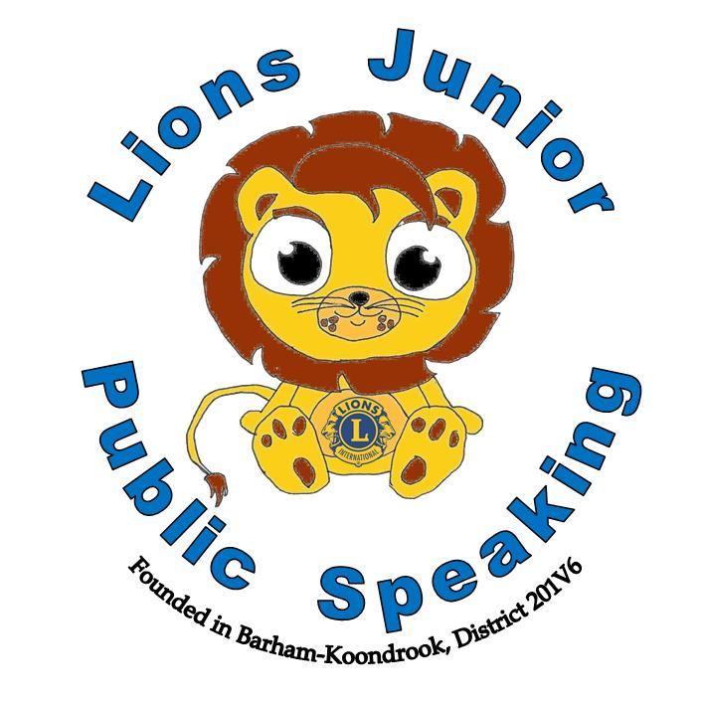

**Most Outstanding Speaker**

Click here to enter text.

Click here to enter text.

Date

Club President

This certificate is awarded to

**Lions Club of** Click here to enter text.

**District** Click here to enter text.

“The World is waiting for YOUR words” ~ Arvee Robinson

This certificate is awarded to

Date

Club President

Lions Junior Public Speaking



**Runner Up**

Click here to enter text.

Click here to enter text.

Date

Club President

This certificate is awarded to

**Lions Club of** Click here to enter text.

**District** Click here to enter text.

“The World is waiting for YOUR words” ~ Arvee Robinson

This certificate is awarded to

Date

Club President

Lions Junior Public Speaking

This certificate is awarded to

Click here to enter text.

**School Final Participant**

Click here to enter text.

Click here to enter text.

Date

Club President

**Lions Club of** Click here to enter text.

**District** Click here to enter text.

“The World is waiting for YOUR words” ~ Arvee Robinson

This certificate is awarded to

Date

Club President

Lions Junior Public Speaking